 | Department: Biomedical Engineering | Course Name: Physiology | College  of Engineering
 | Academic Semester: Fall (2024/2025) | Course Code: BME 308,  BME 309

Project Report
Overview

What is the name of this project?
Answer: Wellness Test Device (Digital Blood Pressure Monitor and Oximeter)

What is the goal of this project?
Answer: To test the wellness of the patient, by measuring blood pressure and SPO2 levels in the blood, and with those two result, the device outputs an understandable result to the user, then the results will be sent to a mobile application.

Design

What components were required for this project, and their prices?
Answer:
- Arduino UNO - 450EGP
- I2C Serial Interface - 60EGP
- 16x2 LCD - 90EGP
- Pressure Sensor - 110egp
- Servo Controlled Valve - 120EGP
- Air pump - 180egp
- PVC Pipe as 3 way splitter and Tubing - 100EGP
- Blood Pressure Cuff And Manual Pump - 200EGP
- TL072 Op-Amp - 8EGP
- Bluetooth Module - 245EGP
- Pulse Oximeter - 110EGP
- Breadboard(s) - 100EGP
- Several Resistors and Capacitors – 15EGP
- Wires – 60EGP
- 9V Battery - 40EGP
- 5V Battery - 22EGP
Total Price: 1910 EGP
What were the steps you took to achieve the goal of this project?
Answer:
The first step in any project is research, research is very important to scope out the project’s requirements and inner workings. Then the material Gathering part comes next, it’s very important to find the exact same components you researched about, and if you don’t find them, you need to have backups. And Then, the implementation step, which includes hardware wiring and coding. Finally, The testing phase of the device.

Implementation

What issues have you faced while implementing these steps?
Answer:
- Research: No issues faced and the research phase was plentiful
- Material Gathering: This was the hardest part, since the part we researched about (Pressure Sesnor and Solenoid Valve) were NOT available in Egypt.
- Implementation: As we discussed in the material gathering phase, the implementation was hard since we didn’t have the researched components. And code was simple enough.
- Testing Phase: No issues faced.

How did you resolve these issues?
Answer:
- Material Gathering Issues: Many necessary components were not readily available in Egypt, and one of them was the Pressure Sensor, which was a very important part for this project, the one that was available was a Chinese variant that had no datasheets online. Same issue with the solenoid air valve, so we used a servo with a pin to push on a plastic to let air out.
- Implantation Issues: The issues with the different components continued in the implantation phase, with unknown pins and new unresearched parts to connect.

Results

What were the outcomes of your project?
Answer:
Approximately Measure MAP of blood pressure and the SPO2 of the oximeter to result in a user friendly outcome for anyone to understand on the lcd screen, and then send the information to a mobile app for more details.

Did you meet your initial objectives?
Answer:
Yes and No, The initial objective BEFORE research was to measure Systolic and Diastolic Pressures and BPM for Readings, but with the part limitations we could only measure MAP.
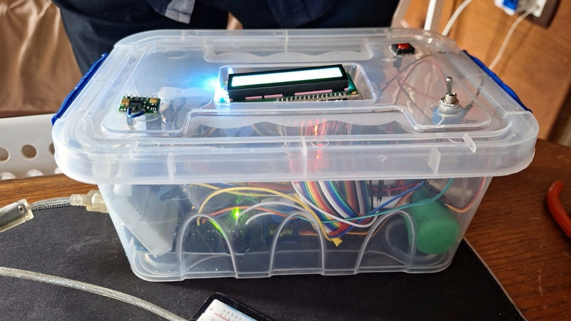

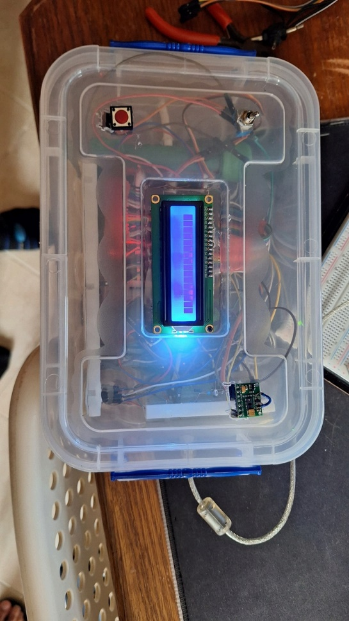
Improvements

Were there any limitations (time, budget, etc.) that affected your project?
Answer:
- More time and research was needed in the middle point of the project deadline since doubling the projects goals was unexpected.
- Academic Limitation has also played a part since we had a lot of exams and other smaller projects to attend to during the weeks.
- Supply Line Limitations, since Egypt did not have the initial necessary components, we had to limit ourselves to more simpler ICs and components.

What improvements would you make with more time and budget?
Answer:
- Order the original parts from overseas since it takes months to arrive.
- The finishing would be more finalized and presentable using 3D printing.
- Ordering more accurate and precise sensors.
- Better screen for readings.
- Custom made application.
- Audio cues for whoever needs it.

Reflection

Each team member must answer the following questions:

Team Member (1):
What is your full name and student ID?
Name: Mostafa Ahmed Ibrahim
ID: 200010417

What specific contributions did you make to this project?
Answer:
- Excessive Research and datasheet collecting
- Simulation on proteus
- Coding Arduino
- Making the presentation video
- Connecting Hardware
- Acting in Video

What skills or experiences did you gain or improve from this project?
Answer:
- Hardware Experience Improvement
- Software and Coding Experience Improvement
- Datasheet Research
- Android Application Integration

Team Member (2):
What is your full name and student ID?
Name: Abdelrahman Osama Mahmoud
ID: 200011613

What specific contributions did you make to this project?
Answer:
- Shopping for components
- Making the custom made 3-way splitter
- Connecting Hardware
- Finalization of the project
- Acting in the presented video.
- Making the report that will be delivered in the presentation day

What skills or experiences did you gain or improve from this project?
Answer:
1- Working under pressure.
2- Improvisation.
3- Making decent reports.
4- DIY skill.
5- Making deep researching

